Chaining: -

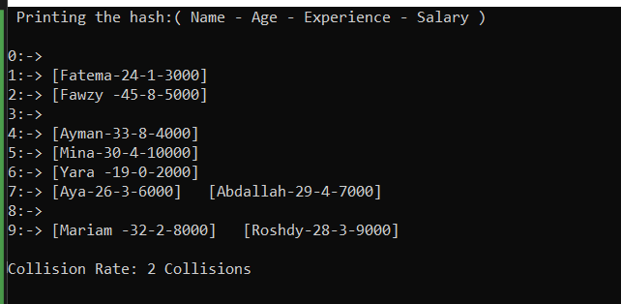

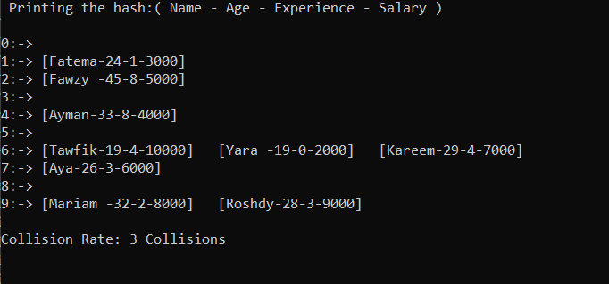

When removing two elements:

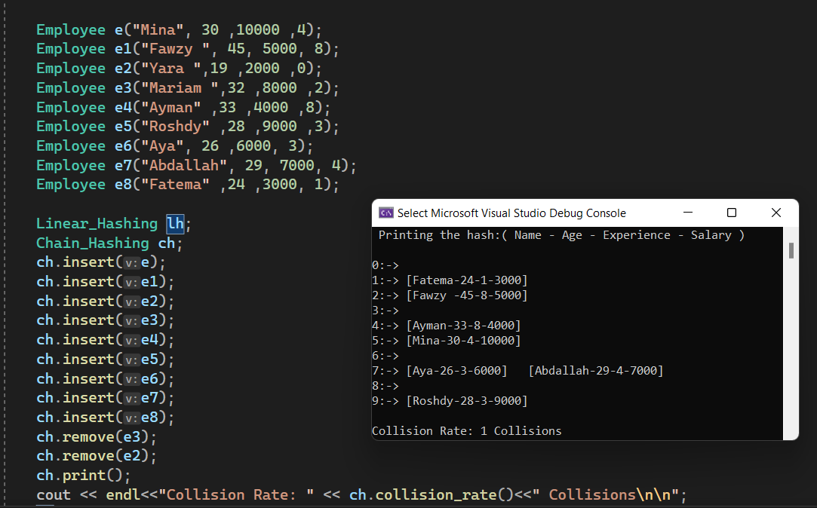



Linear:

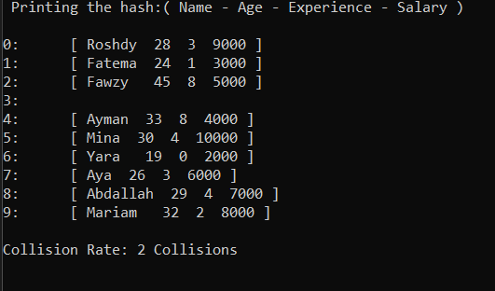

When removing:

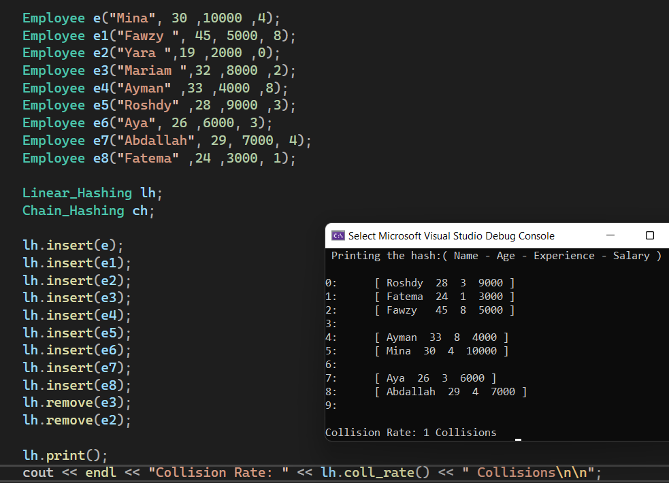



Answers:

* I think that chaining hashing is way better than linear probing.
* The reasons why I think so:
  + It is much more organized and easier to implement.
  + It is open memory, which means that you can add to it as much as you need.
  + You can sort the element in case of collision so that, the searching process would be easier.
  + The algorithm can be understood easily and be presented in a logical way.